Editorial contacts:
Heiko Hespen or Nick Foot
Billings Europe
Tel: +44-1491-636 393
Fax: +44-1491-636 383
heiko.hespen@billings-europe.com

New Catalist features over 800 products

Witham – March 1, 2007 – A new combined price list and catalogue is now available from Crompton Instruments, part of Tyco Electronics – Energy Division. The new full colour Catalist 2007 brochure contains over 800 standard products.

Also included in the new brochure are new products such as the competitive range of elapsed time meters, LCD and LED gen-set controllers, direct connect DIN rail single and three phase energy meters as well as the DIN 96 panel mounted metering system.

What’s more, the new Catalist 2007 brochure features guidelines on delivery lead times for each product.

Tyco Electronics is a trademark.
Crompton is a Trademark of Crompton Parkinson Ltd and is used under licence.

About Tyco Electronics – Energy Division
The Energy Division of Tyco Electronics is a global manufacturer of products and systems for the electrical power industry. Its products are extensively employed by power utilities and equipment manufacturers, in rail transport systems and in industry around the world.
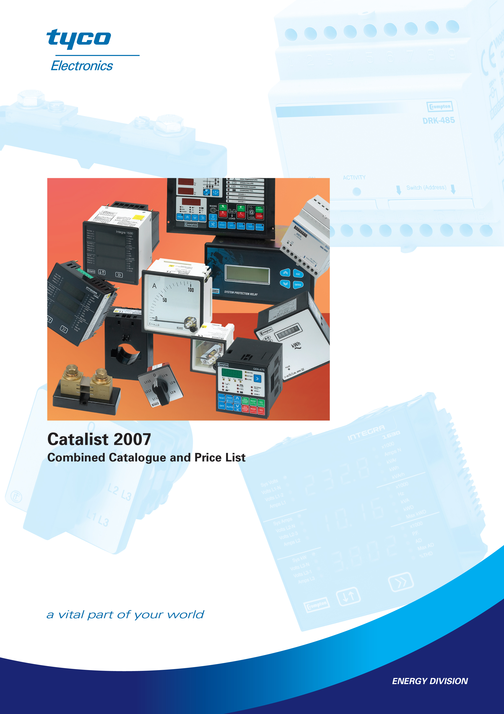
The Energy Division of Tyco Electronics offers a wide product range from brands such as AMP, Axicom, Dulmison, Raychem, SIMEL, Bowthorpe EMP, Crompton Instruments, Dorman Smith and La Prairie, including cable accessories, connectors and fittings, switching and power management devices, lighting protectors, surge arrestors and insulators.
For further information please visit: www.energy.tycoelectronics.com

About Tyco Electronics
Tyco Electronics is a leading global provider of engineered electronic components, network solutions and wireless systems, with 2006 sales of $12.7 billion to customers in 150 countries. We design, manufacture and market products for customers in industries from automotive, appliances and aerospace and defence to telecommunications, computers and consumer electronics. With over 8,000 engineers and worldwide manufacturing, sales and customer service capabilities, Tyco Electronics' commitment is our customers' advantage. More information on Tyco Electronics can be found at www.tycoelectronics.com

For further information please refer to www.energy.tycoelectronics.com or contact:

Pavlina Dvorakova, Marketing Communications Coordinator,
Tyco Electronics – Energy Division, Witham, UK,
Tel: +44 (0)1376 509 509, Email: pavlina.dvorakova@tycoelectronics.com

